In the thesis, Arduino IDE (Integrated Development Environment) software written in Java language is programmed and servo motor driven is provided. Thus it is possible to perform the desired operations by means of the elements located on the Arduino without any circuit construction other than the circuit where the servo motor inputs are located. For mechanical part, the robotic arm frames are drawn with the CorelDraw software and the dimensions of the robotic arm are specified. A 5V power supply is also preferred for the robot to work.

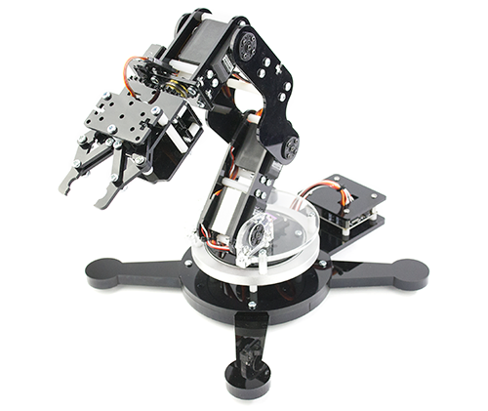

Figure 1.1. Robotic arm

**1.2. Aim and Objectives**

The general objective of this thesis is to develop an algorithm to make a robotic arm capable of accomplishing pick-and-place operations. Such operations involve moving an objective from an initial to a final given position using android controller application. After reviewing the literature of previous thesis done about manipulator motion, specific objectives were established.

The specific objectives include:

* + - To define the entire workspace of the manipulator in order to design paths with reachable configurations
    - To select components for working long time operations of robotic arm.
    - To design the algorithms for controller and driver to perfectly accomplish robotic arm’s operations.
    - To evaluate the effectiveness of the proposed method by comparing the theory and experimental results.

**1.3. Scope of Thesis**

The motion of this robotic arm is limited to a circular path that means the robotic arm can move in an autonomy of degree. For example, the volume and the area of sphere is 4/3r2 and 4r2 respectively, so the movement and motion of the robotic arm was restricted according to the formula. Any duty which can be done by the movement along the circulator shape of sphere can be performed by this robotic arm if the written code is matched. Arduino Uno is used as driver, generally the reset circuitry and power setup will be ready especially the circuitry of programming and Bluetooth communication. The body and some special part of robotic arms can be done with fireboard, servo motors, bearings, screws and jumper wire. For the wireless control device, android phone is used with Robotic Arm Controller application.

**1.4. Implementation Program**

The Implementation procedure are following:

* To find the design fundamental for robotic arm
* To select the best material used to build the robotic arm
* To design the circuit for driver and the program for controller
* To test the implemented robotic arm

**1.5. System Overview**

In this thesis, Robotic arm is designed with scrap material and servos. The arm has been built with fiber and the individual parts have been locked to servo motors. Arduino Uno is programmed to control servo motors. Servo are serving as joints of robotic arm. This setup also looks as a robotic crane or it can be converted into a crane by some easy tweaks.

These servos can be moved by rotating the arms to pick some object, with some practice the object can be easily picked and moved from one place to another. Low torque servos can be used here but more powerful servos can be used to pick heavy objects. Robotic arm which can be controlled remotely by an Android phone. It also can receive commands via Bluetooth and work accordingly. Develop an Android application which allows the user to send commands via Bluetooth. Commands received by Bluetooth modem connected to Arduino microcontroller. Microcontroller drives servo motors which allows the movement of robotic arm in all directions and gripper to handling physical objects.

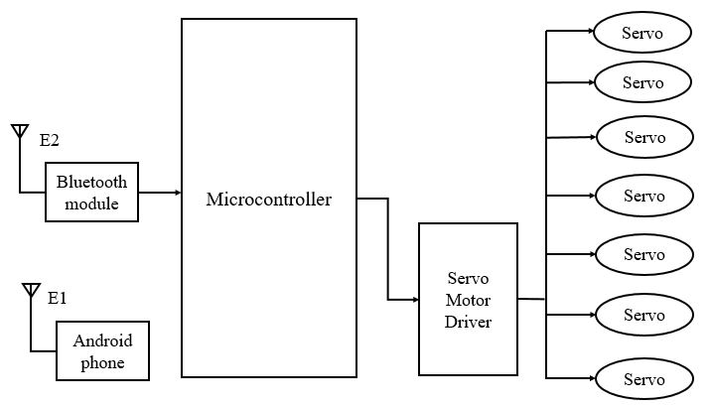

Figure 1.2. Overall System Block Diagram

**1.6. Outline of the Thesis**

During the course of this thesis, certain issues had to be addressed which was critical to the overall success of the thesis. These issues can be categorized into four separate sections. They are android software implementation, Arduino software implementation, circuit implementation and hardware implementation.

**1.7. Layout of the Thesis**

In this thesis organized as follow, chapter two describes the overview of the robotic arm. In chapter three, the design of the robotic arm followed by mechanical parts. Android software implementation of the robotic arm will be mention in chapter four. In chapter five, the test and result of the robotic arm will be described. In the end, a short conclusion is drawn in chapter six.